**𝐀 𝐍𝐨𝐯𝐞𝐥 𝐌𝐞𝐭𝐡𝐨𝐝 𝐅𝐨𝐫 𝐇𝐚𝐧𝐝𝐰𝐫𝐢𝐭𝐭𝐞𝐧 𝐃𝐢𝐠𝐢𝐭𝐚𝐥 𝐑𝐞𝐜𝐨𝐠𝐚𝐧𝐢𝐭𝐨𝐧 𝐒𝐲𝐬𝐭𝐞𝐦**

**Abstract**

Handwritten digit recognition has recently been of very interest among the researchers because of the evolution of various Machine Learning, Deep Learning and Computer Vision algorithms. In this report, We compare the results of some of the most widely used Machine Learning Algorithms likeCNN- convolution neural networks and with Deep Learning algorithm like multilayer CNN using Keras with Theano and Tensorflow. MNIST is a dataset which is widely used for handwritten digit recognition. The dataset consist of 60,000 training images and 10,000 test images.The artificial neural neworks can all most mimic the human brain and are a key ingredient in image processing field.For example Convolution Neural networks with back propagation for image processing.The applications where these handwritten digit recognition can be used are Banking sector where it can be used to maintain the security pin numbers, it can be also used for blind peoples by using sound output.

**Introduction**

In recent decades, the image classification problem has been widely addressed in theliterature, and it is still an active research field in image processing today. In this field,convolutional neural networks have made a substantial breakthrough in visual recognition,especially handwritten digit recognition . These networks have a great ability for learning and extracting image features easily. CNN architectures for image classification havetwo different types of layers: convolutional layers for extracting image features and fullyconnected layers for performing the classification task based on the features extracted bythe preceding convolutional layers . The handwritten digit recognition problem isa topic of heated debate in recent years. Despite that there are enormous convolutionalneural network algorithms proposed for handwritten digit recognition, issues such asrecognition accuracy and computation time still require further improvement . In theliterature, there are massive studies based on different techniques that have been proposedfor handwritten digit recognition: in , Ali et al. have used MNIST handwritten digits as adataset. The authors proposed to utilize DL4J framework for handwritten digit recognitionand convolutional neural network as a classifier, and they achieved a reasonable accuracyof 99.21%.Schaetti et al. proposed to utilize the reservoir computing paradigm to classify MNISThandwritten digit images, and they achieved an accuracy of 93%. The authors claim thattheir model outstrips other models such as simple feedforward networks with regard toerror rate and complexity .Hermans et al. have addressed the MNIST handwritten digit classification problem. In this context, 10 iterations are used for each image in the MNIST dataset; in otherwords, each input digit is repeated for 10 masking periods. In their experiments, the authors focused on both an MNIST handwritten digit classification dataset, and a TIMITphoneme classification dataset. In both MNIST and TIMT datasets, the authors found thatoptimizing the input encoding can make great improvements over random masks.

**METHODOLOGY**

Deep Learning has emerged as a central tool for self-perception problems like understanding images, voice from humans, robots exploring the world. The project aims to implement the concept of Convolution Neural Network which is one of the important architecture of deep learning. Understanding CNN and applying it to the handwritten recognition system, is the major target of the proposed system .There is a reason behind using CNN for handwritten digit recognition. Let us consider a multi-layer feedforward neural network to be applied on MNIST dataset which contains images of size 28×28 pixels (roughly 784 pixels). So if a hidden layer has about 100 units, then the first layer weights comes up to about 78k parameters, which is large but manageable. However, in the natural world the size of the image is much larger . If we consider the size of the typical image which is around 256×256 pixels (roughly about 56,000 pixels), then the first layer weights will have about 560k parameters! So that becomes too many parameters and hence make it unscalable for real images. Hence, it will be so large that it will become very difficult to generalize the new data fed into the network. Convolution Neural Network extracts the feature maps from the 2D images by applying filters and hence making the task of feature extraction from the images easier. Basically, convolution neural network considers the mapping of image pixels with the neighbourhood space rather than having a fully connected layer of neurons. Convolution Neural Networks has been proved to be a very important and powerful tool in signal and image processing. Even in the fields of computer vision such has handwriting recognition, natural object classification and segmentation, CNN has been a much better tool compared to allother previously implemented tools .The broader aim in mind was to develop a M.L. model that could recognize people's handwriting. However, as we began developing the model we realized that the topic in hand was too tough and would require tremendous data to learn. Example to accurately classify a cursive handwriting will be very tough. Thus we settled on classifying a given handwritten digit image as the required digit using three different algorithms and consequently testing its accuracy. Proposed System of handwritten digit recognition.

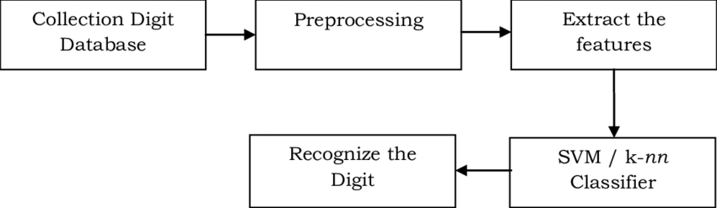

**Algorithm:**

**Forward Propagation:**

Architecture: This is a small workflow of how CNN module will extract the features and classify the image based on it. The architecture shows the input layer, hidden layers and output layer of the network. There are many layers involved in the feature extraction phase of the network which involves convolution and subsampling .

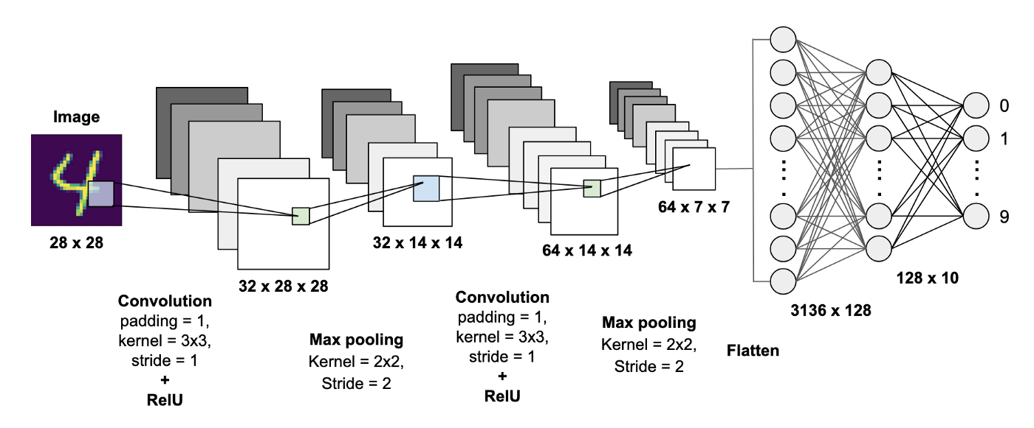

**RESULTS**

As with any work or project taken up in the field of machine learning and image processing we are not considering our results to be perfect. Machine learning is a constantly evolving field and there is always room for improvement in your methodology; there is always going to be another new approach that gives better results for the same problem. The application has been tested using three models: Multi-Layer Perceptron (MLP), Convolution Neural Network (CNN). With each model we get a different accuracy of the classifier which shows which one is better. The results of training the network is stored in .npz format so that whenever a user tries to recognize the digit, the application does not go into the training loop again. For classification, we have used logistic classifier, softmax function, one hot encoding, cross entropy and loss minimization using mini batch gradient descent. These are some of the basics of Neural Network which are required to process the output from the network and display in the form the user can understand.

**A.DATASET USED**

The dataset used is the MNIST database of handwritten digits.It consists of a training set of 60,000 examples, and a test set of 10,000 examples.The digits have been size-normalized and centered in a fixed-size image.The images are of size 28*28 pixels.It is a good database for people who want to try learning techniques and pattern recognition methods on real-world data while spending minimal efforts on preprocessing and formatting. The dataset istaken fromhttp://yann.lecun.com/exdb/mnist/

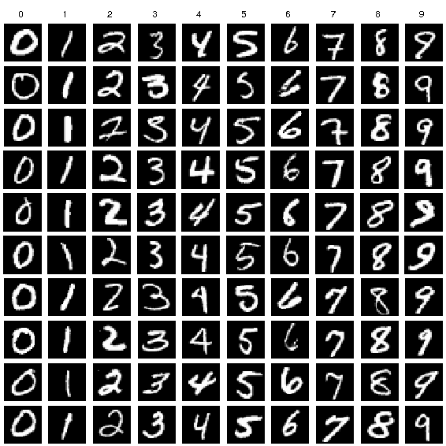

**B. ANALYSIS OF THE RESULTS:**

In business, System Analysis and Design refers to the process of examining a business situation with the intent of improving it through better procedures and methods. System analysis and design relates to shaping organizations, improving performance and achieving objectives for profitability and growth. The emphasis is on systems in action, the relationships among subsystems and their contribution to meeting a common goal. Looking at a system and determining how adequately it functions, the changes to be made and the quality of the output are parts of system analysis. Organizations are complex systems that consist of interrelated and interlocking subsystems. Changes in one part of the system have both anticipated and unanticipated consequences in other parts of the system. The systems approval is a way of thinking about the analysis and design of computer based applications. It provides a framework for visualizing the organizational and environmental factors that operate on a system. Proposed Application Module: The proposed application has been implemented using Python on terminal. The user is given two options in the home image: Simple Upload, Model Form Upload. Simple Upload will allow the user to upload the image and predict it then and there. After navigating away from that page, the link to the uploaded image is lost. The Model Form Upload will allow the user to upload the image with description. With this link, the user will be able to store the image and see its link on the home page itself. By clicking on the link, the user will be able to get the result from the CNN classifier.

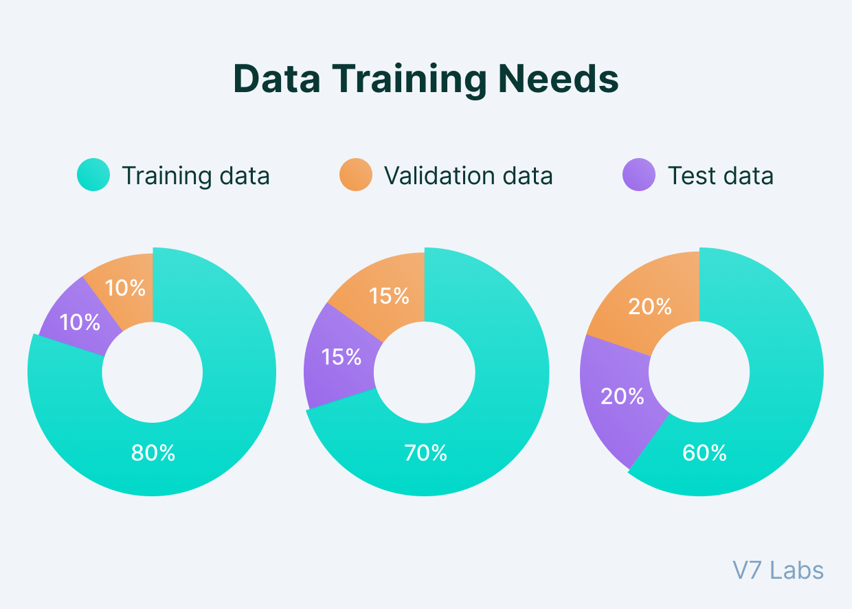

**CONCLUSION**

An implementation of Handwritten Digit Recognition using Deep Learning has been implemented in this paper. Additionally, some of the most widely used Machine Learning algorithms i.e. CNN using Tensorflowhave been trained and tested on the same data to draw a comparison as to why we require deep learning methods in critical applications like Handwritten Digit Recognition. In this paper, I have shown that that using Deep Learning techniques, a very high amount of accuracy can be achieved. Using the Convolutional Neural Network with Keras and Theano as backend, I am able to get an accuracy of 95.72%. Every tool has its own complexity and accuracy. Although, we see that the complexity of the code and the process is bit more as compared to normal Machine Learning algorithms but looking at the accuracy achieved, it can be said that it is worth it. Also, the current implementation is done only using the CPU Thus we settled on classifying a given handwritten digit image as the required digit using three different algorithms and consequently testing its accuracy. In future we are planning to further explore the topic to recognize people’s handwriting.